Summary Statistic:

Minimum: 0.126

Maximum: 4.345

Mean: 1.1599466666666667

Median: 0.943

Variance: 0.7328737809009009

Coeff. of Variance: 0.7380343427128377

Lexis Ratio: 0.6318167912038205

Skewness: 2.1265552574071966

\*\*\*\*\*\*\*\*\*\*\*\*\*\*\*\*\*\*\*\*\*\*\*\*\*\*\*\*\*\*\*\*\*\*\*\*\*\*\*\*\*\*\*\*\*\*\*\*\*\*\*\*\*\*\*\*\*\*\*\*\*\*\*\*\*\*\*\*\*\*

Result:

There is no specific domain for generated data. So, sample dataset is continuous.

Mean > Median :: Not Symmetric.

Skewness > 0 :: Skewed to Right.

Coefficient of variation < 0 :: Weibull or Gamma.

Histogram:

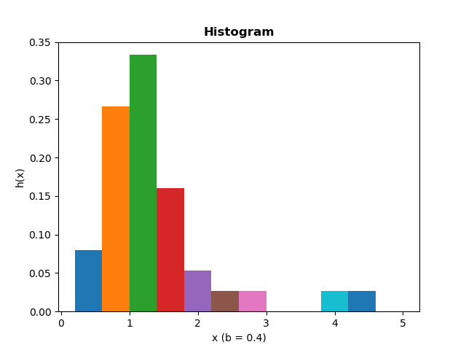

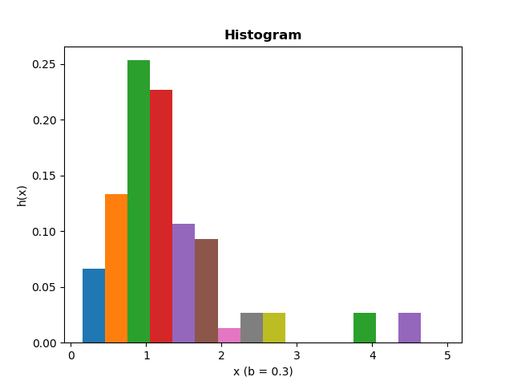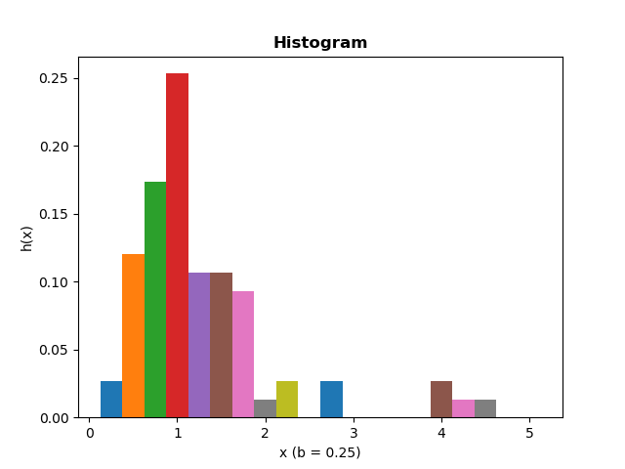

We can see relatively smooth-looking shape occurs at Del(b)= 0.3, with k=17 number of intervals.

Morever, the shape of the Histogram resembles with that of a Weibull density.

Quantile Summaries and Box Plot:

Median: 0.943

Quantile[0]: 0.664

Quantile[1]: 1.436

Quantile Midpoint: 1.05

Octile[0]: 0.477

Octile[1]: 1.657

Octile Midpoint: 1.067

Extreme[0]: 0.126

Extreme[1]: 4.345

Extreme Midpoint: 2.2355

We can see midpoints are gradually increasing. So, underlying Distribution is Right Skewed.

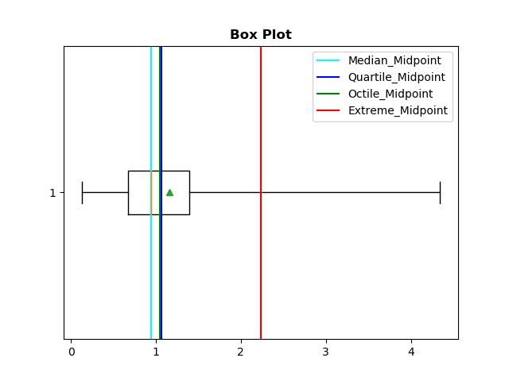

The elongated nature of the right side of the box plot reaffirms our hypothesis that it is right skewed.